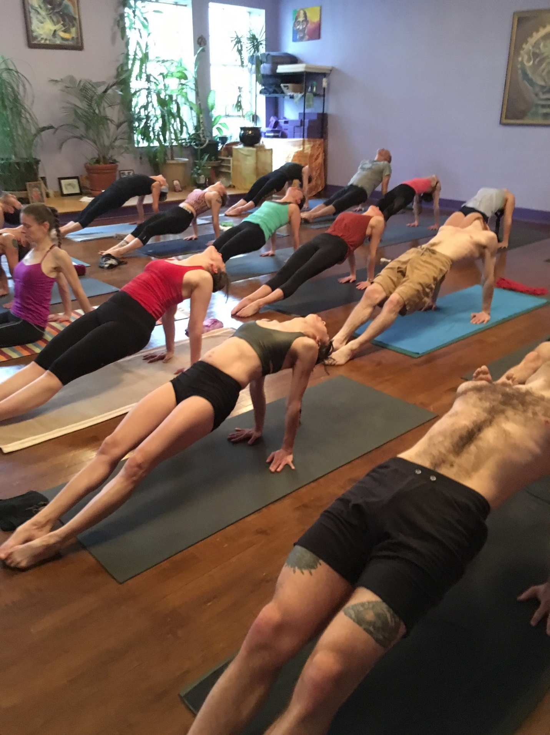

FebruaRy 15th - March 14th  M/T/Th/F 7-8am $135

C

To Register Email [vivian@bandharoom.com](mailto:vivian@bandharoom.com)

at The Bandha Room

119 ½ Capitol Way N

Olympia, WA 98506



Ashtanga yoga

Mysore immersion