ASHTANGA YOGA MYSORE IMMERSION

Learn the Traditional Morning Mysore Style Practice at The Bandha Room !

Sunday September 24th – Special Workshop 8-10am

September 25th – October 20th Mondays, Tuesdays, Thursdays, Fridays 7-8am

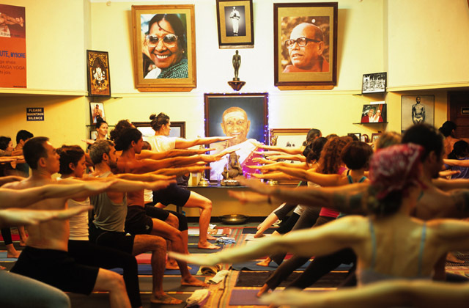

$125 Graduates receive a $50 discount on their next month!

119 ½ Capitol Way N (Capitol and State) Register: vivian@bandharoom.com

