ANAHata chakra

Bathe your Heart in Breath

A 4th Chakra Workshop

to Open and Strengthen the Heart Space



Sunday December 3rd 9am to 11am $20

The Bandha Room Ashtanga Yoga Studio

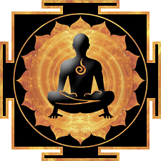

119 ½ Capitol Way N email: vivian@bandharoom.com