BREATHE
Breath Controls Mind Mind Controls Body
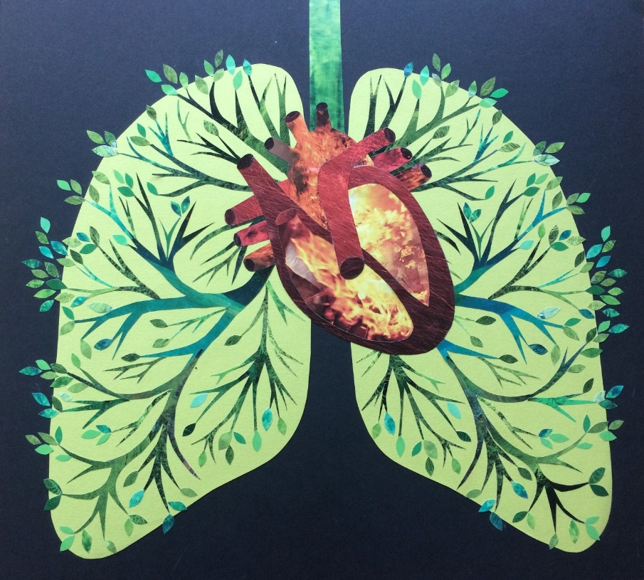
Monday November 27th 5:30-7pm $20
Learn Breath Control and Refinement
Bring Energy and Power to your Practice and your Life
The Bandha Room 119 ½ Capitol Way N
Email vivian@bandharoom.com to register

