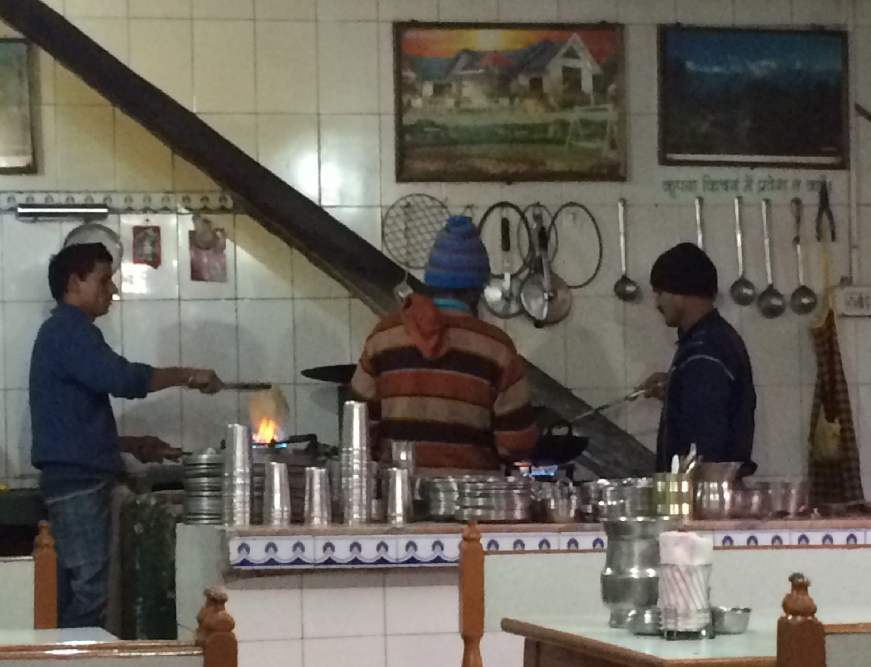  - Saturday April 14 4 pm  vivian’s birthday feast and mysore fundraiser  -suggested donation $20-$100, no one turned away  Join us as we celebrate Vivian’s run for 50… As always Vivian will whip up an authentic South Indian meal and share stories of other great eats. Proceeds from this event will help cover tuition and travel expenses for this Summer’s yoga session in Mysore. | Some old favorites will mingle with new tastes… -  Bisi Bele Bath -  Kosambari -  Raw Mango Pie -  And of course… there will be CHAI !  secret location  -  Sign guest list for details…

